2018 HAVIN Insight Expo

Preparing for the Seasons

A Half-Day of Information and Networking
For the Blind and Visually Impaired
Exhibits, Workshops and Door Prizes

DATE: April 14, 2018
TIME: 9:00 AM to 2:00 PM
REGISTRATION: 8:30 AM

University of Houston – Main Campus
Health and Biomedical Sciences Building
4901 Calhoun
Houston, Texas 77004

SPONSORED BY THE HOUSTON AREA VISUALLY IMPAIRED NETWORK, (HAVIN)
HAVIN Insight Expo 2018 Registration Instructions

The Insight Expo 2018, sponsored by the Houston Area Visually Impaired Network (HAVIN), is now set and the only thing missing is you! This will be a half-day event with a focus on Preparing for the Seasons! speakers and workshops for the blind and visually impaired. For those who take advantage of pre-registration, you will be entered into a drawing for a special door prize. Breakfast, workshops, discussion panels, and door prizes, all for only $10!

Please complete all information on the Registration Form on the next page and submit the form via email to havin.tx@gmail.com. If you are unable to fill out the form electronically, please call Stacie Hardy at (832) 779-7477. Be sure to indicate the type of electronic payment on the form. If paying by check, send the payment to the mailing address shown on the Registration Form (check payable to HAVIN). Directions to the event are shown on the last two pages of the Registration Form. Bring the signed Media Release form (separate attachment) with you to the event.

Pre-registration Fee: $10 per person (NO REFUNDS). The deadline to pre-register is Friday, April 6, 2018. Remember, pre-registering allows your name to be entered into a drawing for a special door prize. The drawing will take place during the opening ceremonies of this year’s Expo. For those who wish to register on the day of the event, the cost will remain the same. However, you will not be entered into the special door prize drawing.

Pre-registration Deadline: April 6, 2018.

Electronic payment is preferred by using the Square Cash app (to $HAVINTX) or PayPal (to havin.tx@gmail.com) on your iPhone or Android device or by computer.

If you have any questions, please contact Stacie Hardy at (832) 779-7477 or via email at havin.tx@gmail.com

HAVIN Insight Expo 2018 Registration Form
Pre-register BY April 6, 2018

* Attention Group leaders: Please list all attendees from your group below (make additional copies of the form as necessary). Please submit a single form of payment (Square Cash App, PayPal, or Check) for the entire group.

NAME | PHONE | EMAIL

Total number of registrants:
Total payment enclosed:
Type of payment: Square Cash App _____ PayPal _____ Check _____
Make checks payable to: HAVIN

How did you hear about this event?

RETURN COMPLETED REGISTRATION FORM VIA EMAIL TO havin.tx@gmail.com

SEND CHECKS BY U.S. MAIL TO:
HAVIN c/o Belinda Skloss
22 Ranchview Drive
Huntsville, TX 77320

HAVIN INSIGHT EXPO 2018 MAP & DRIVING INSTRUCTIONS

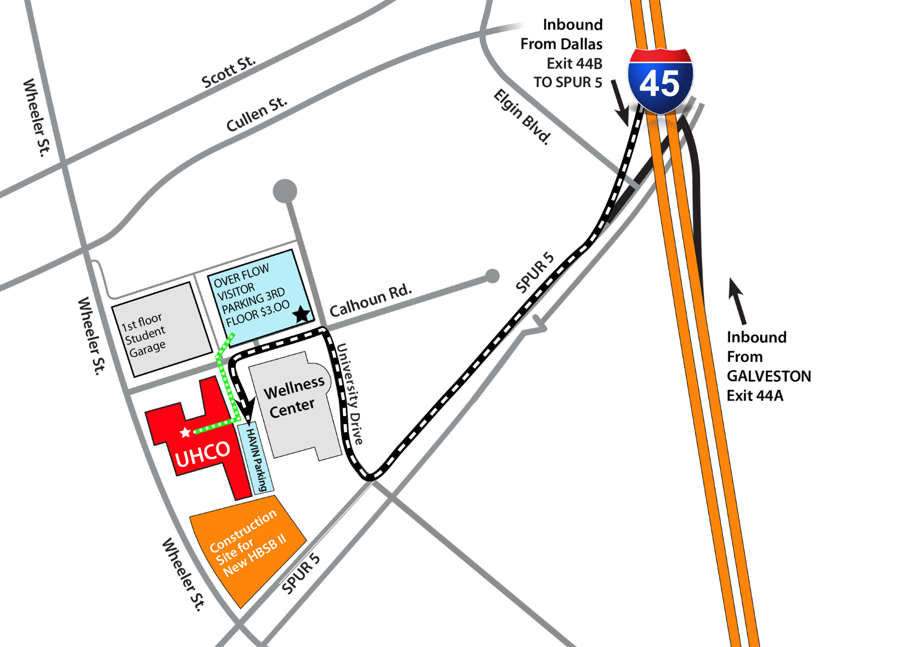

University of Houston – Main Campus
Health and Biomedical Sciences Building (Marked UHCO on MAP)
4901 Calhoun
Houston, Texas 77004

Traveling northbound on I-45:
- Exit Elgin-Lockwood/Cullen.
- Turn left on to Elgin.
- Travel to the 2nd light and turn left on to SPUR 5.
- Travel to the 1st light and turn right on to University Drive.
- Travel to the next light and turn left on to Calhoun.
- Entrance (#2) to the Patient & Visitors Parking Lot will be located on the left, past the Wellness Center and between the buildings marked UHCO on the map.
Traveling southbound on I-45:
- Exit SPUR 5 south.
- Travel to the 1st light and turn right on to University Drive.
- Travel to the next light and turn left on to Calhoun.
- Entrance (#2) to the Patient & Visitors Parking Lot will be located on the left, past the Wellness Center and between the buildings marked UHCO on the map.

Overflow Parking is available across the street in the Welcome Center Garage. Visitor parking is on the 3rd floor and up. The weekend parking rate is $3.

